Big Mountain Resort is one of many Skiing resorts in the US, and is based in Montana. The resort recently installed a new chair lift and is looking towards improving profits as a resort with their new operational costs; specifically Big Mountain is looking to update its ticket prices. Currently their ticket prices were created purely by comparing their prices to other resorts in the business, and did not account for differing facilities and amenities offered by individual resorts.

With the given data, my final conclusion is to increase the price of their adult ticket prices to as high as $95 per ticket, and within a range of $9 of that. Detailed analysis of the data shows that some of the key amenities and facilities for skiing resorts included total vertical drop, snow making equipment, total chair lifts, total runs, and other transportation equipment such as quads and trams; Big Mountain is shown to have more of these amenities and facilities compared to its competitors on average, and generally is only below other resorts with outliers of these figures. Below are some figures that show how Big Mountain has more chairs, runs, and skiiable area than most of its competitors

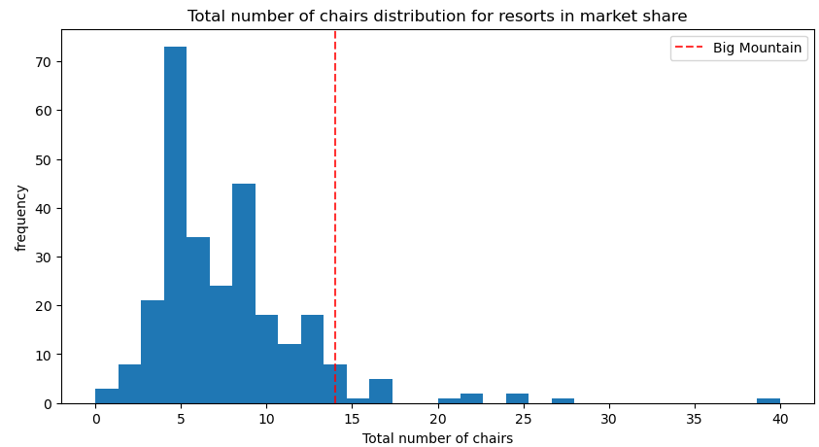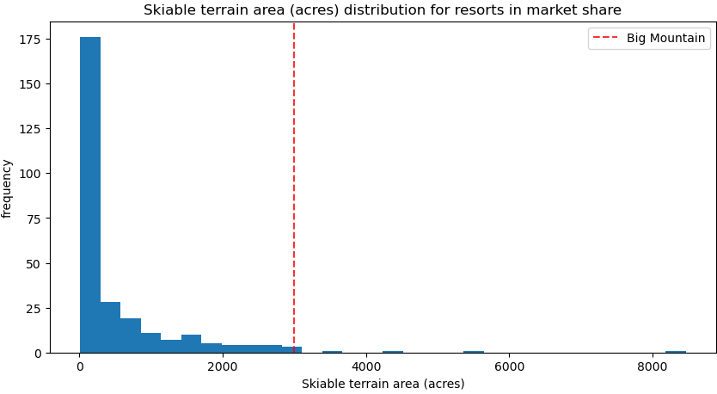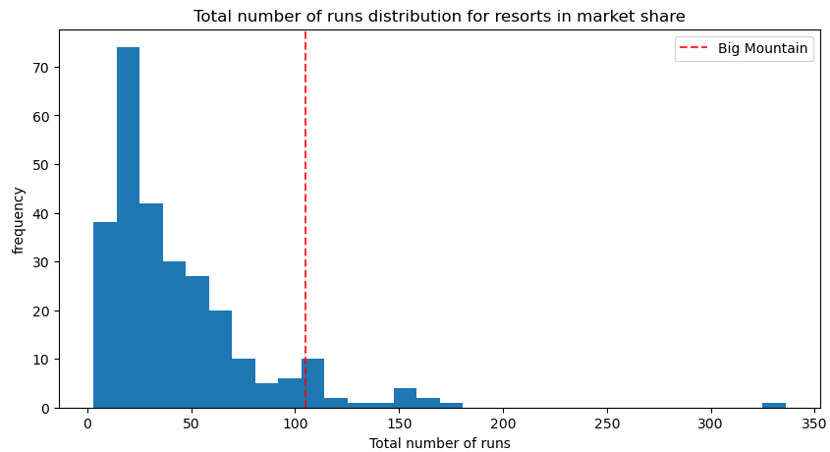

Despite having such a large resort, currently Big Mountain has ticket prices that are more in the middle of its competitors. While the current ticket price of $81 is above the current average of $64 per weekend ticket, it can be seen in the data that a majority of these resorts offer less of a skiing experience and that people are willing to pay for more outside of Montana for less skiing opportunities from the chart below. It should however be noted that within the state of Montana that Big Mountain is in the upper end of ticket prices and if there were a reason to not increase the ticket price fully up to $95 immediately it would be due to the stark difference in prices between Big Mountain and other Montana resorts

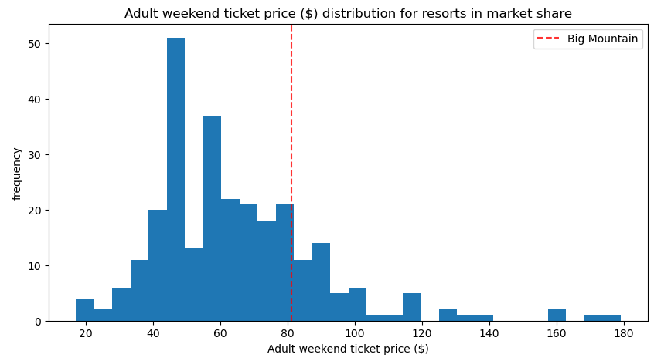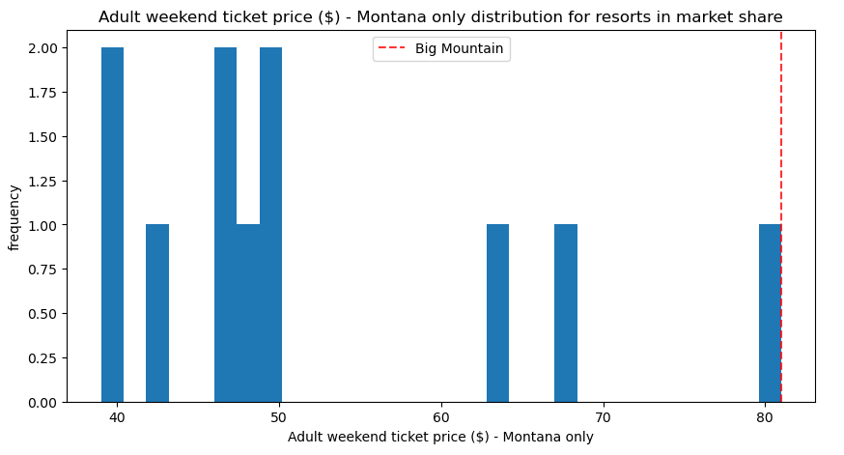

Another idea brought up by Big Mountain management to increase total revenue for the resort was to actually reduce the number of runs available. While the model shows that runs are a major reason why the ticket prices can be increased, it also shows that some amount of runs can definitely be removed due to the volume of runs the resort has. In the figure below, the predictive model shows both how Big Mountain should consider updating ticket prices and the expected loss of revenue caused by this change in available runs. We can easily see here that there is only a minor loss in profits if up to 5 runs are lost and only after that will there be any significant loses; this model does not account for maintenance costs (as it was not within the given data) and it is sure to have a varying change in revenue as a result. Regardless of the decision made by management, it should be noted that any change of the number of runs should be done gradually to account for any variance within the mode